Fresh milk/egg pasteurizer

Equipment introduction
Pasteurization machine for fresh milk bar/egg liquid is suitable for individual households, community shops and vegetable markets to sell pasteurized milk by themselves, or to complete the previous sterilization process before using fresh milk as raw material to make yogurt. After the sterilization, it can also be kept warm and used for rapid cooling．

Equipment features:
2.1 The sterilization temperature and the time to maintain sterilization after reaching the sterilization temperature can be set．
2.2 Power saving, heating fast. Direct heating of milk, energy saving, rapid heating, no milk paste．
2.3 Add stirring device to ensure uniform temperature of each part and no milk crust in sterilization．
2.4 Using the company's patented cooling device, less waste water, cooling fast.
2.5 Stainless steel manufacturing, beautiful, sanitary, long life．

Device profile
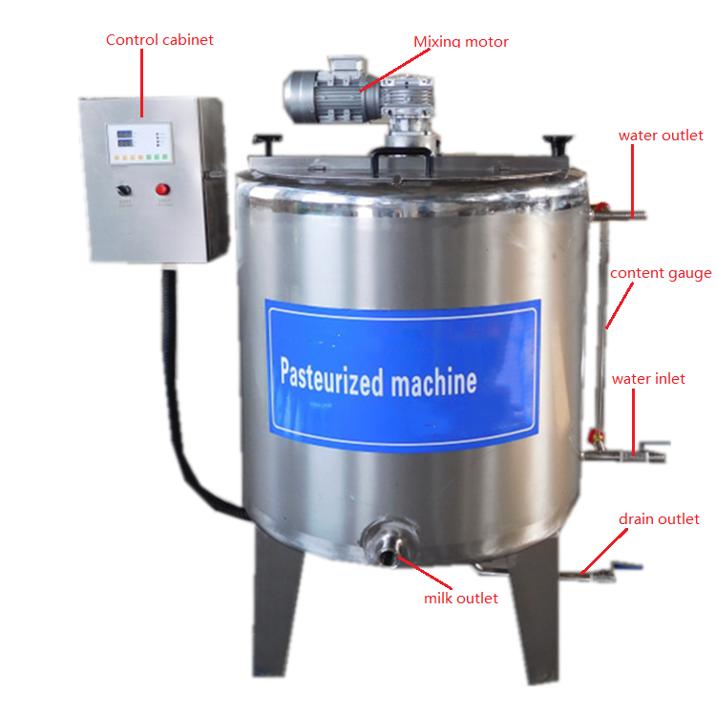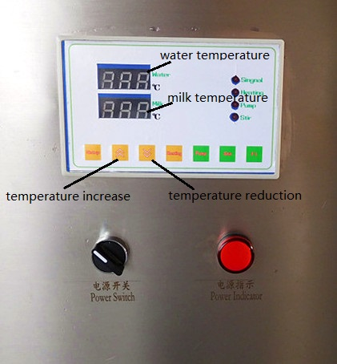

Operation Control Procedure
4.1 Connect the power line, and the user shall prepare 6 square national standard copper wires of 4 lines (equipment power: 9kw, voltage: 380v) to connect to the terminal post of the electric control box．
4.2 Connect the water source, the user shall prepare the hose, and connect the water source and the water inlet of the equipment with the hose．
4.3 The water into the jacket, to the position of more than two-thirds of the liquid level meter, the water switch open, the water inlet switch open, the water level up to more than two-thirds of the liquid level meter can be．

4.4 Turn on the power switch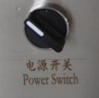，The power indicator lights up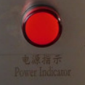. According to the setup，up and down keys，Set the "water temperature" (the water temperature is close to the milk temperature of sterilization), and start heating by heating equipment. During the working period, in order to heat the material evenly, intermittent stirring can be started．
4.5 When the display temperature reaches the set temperature, the heating time can last for 10-15 minutes to stop working and turn off the machine．
4.6 Cooling, the machine turned off the power, open the sewage outlet, the jacket of the hot water, and then turn off the sewage outlet．Then open the water source and water inlet to start water injection, which is to open the mixing function of the machine and cool down quickly．

Matters needing attention
5.1 The power line must be a national standard copper wire of more than 10 square meters．
5.2 Before starting the machine, more than two-thirds of the water must be injected into the jacket．
5.3 If the above problems occur machine damage, not within the scope of the manufacturer's warranty．

